**Dxc _assignment _day-3**

**Shaik Mohammed Raihan**

**Case study-3**

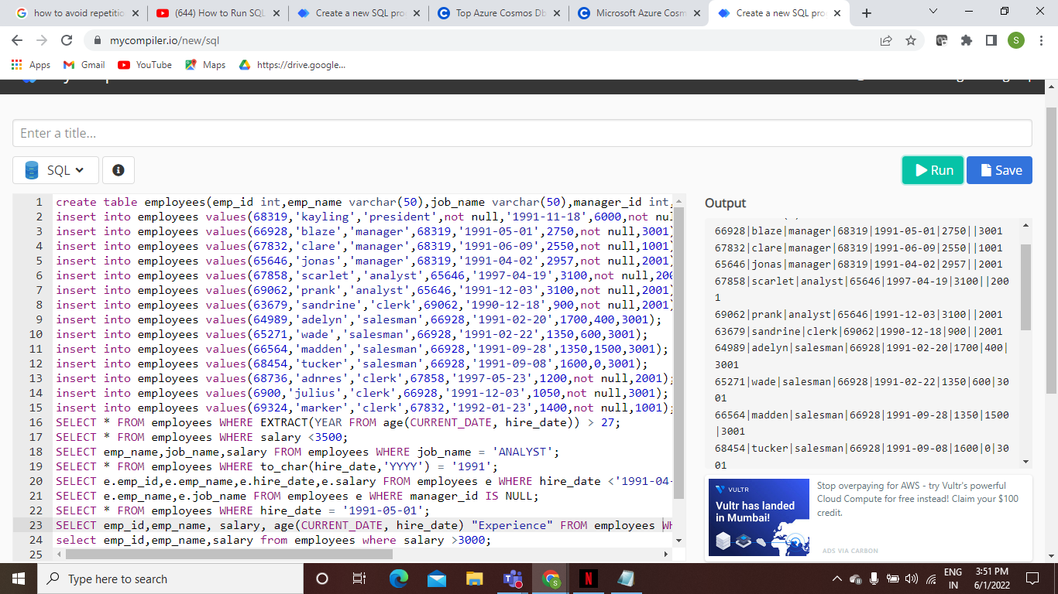

**Quires:-**

SELECT * FROM employees WHERE EXTRACT(YEAR FROM age(CURRENT_DATE, hire_date)) > 27;

SELECT * FROM employees WHERE salary <3500;

SELECT emp_name,job_name,salary FROM employees WHERE job_name = 'ANALYST';

SELECT * FROM employees WHERE to_char(hire_date,'YYYY') = '1991';

SELECT e.emp_id,e.emp_name,e.hire_date,e.salary FROM employees e WHERE hire_date <'1991-04-01';

SELECT e.emp_name,e.job_name FROM employees e WHERE manager_id IS NULL;

SELECT * FROM employees WHERE hire_date = '1991-05-01';

SELECT emp_id,emp_name, salary, age(CURRENT_DATE, hire_date) "Experience" FROM employees WHERE manager_id=68319;

select emp_id,emp_name,salary from employees where salary >3000;

select emp_name from employees where hire_date+interval'96 months'>'1999-12-31';

select * from employees where mod(salary,2)=1;

select * from employees where length(salary)=3;